 | CHAROTAR UNIVERSITY OF SCIENCE & TECHNOLOGY  DEVANG PATEL INSTITUTE OF ADVANCE TECHNOLOGY AND RESEARCH | 

Weekly Report
In this report students require to mention the work has been done during the week and planning for the next week. (Please fill individual report for each week)

Student ID: 18dce057 | Student Name: Shraddha Mehta
From Date:17/05/2020 | To Date:23/05/2020
Semester : 4 | Internship ID: 30

Work done in last week (Attach supporting Documents):

- I have made forgot password Activity

With help of forget password activity user can retrive their password with help of answering some security questions which was answered by that user previously….
This feature is very supportive and beneficent for user..

This is snapshot of Forget password or reset password activity where user have to enter their details like phone number and have to answer security questions which was set by themselves ..

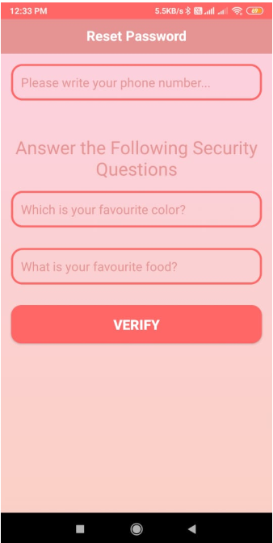 | 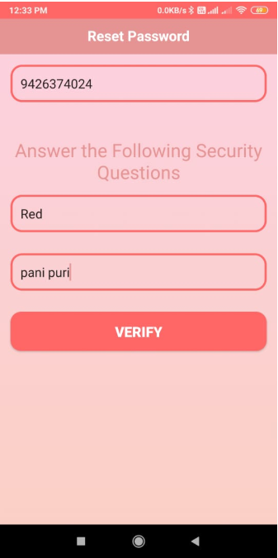

If user has given correct answers then dialog box will open and user can change their password..

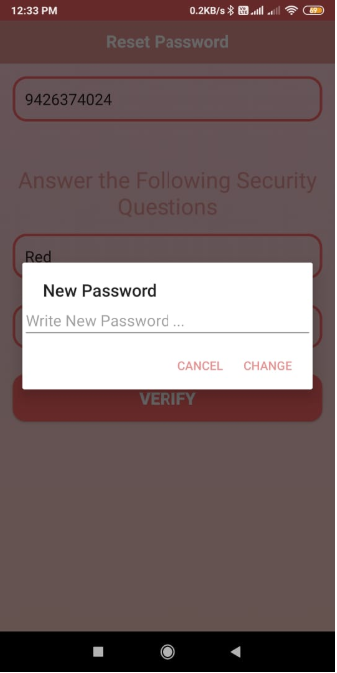 | 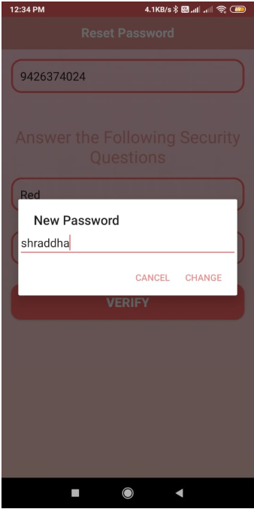

- I have made search products Activity

This Activity is very helpful for user where user can search products by name..

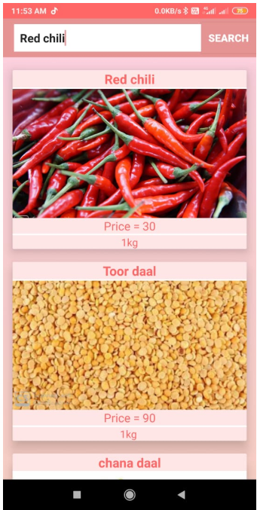 | 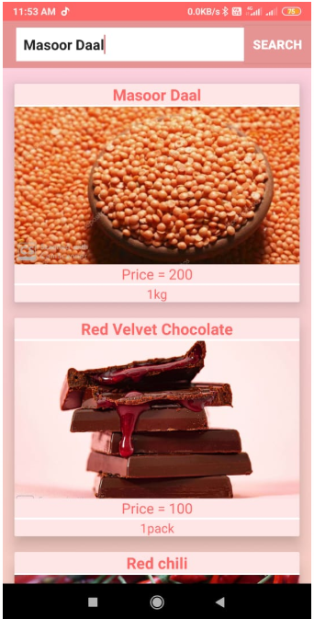

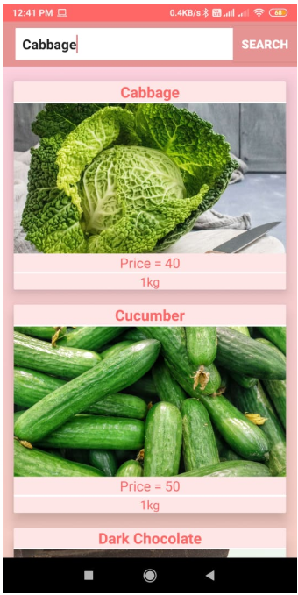 | 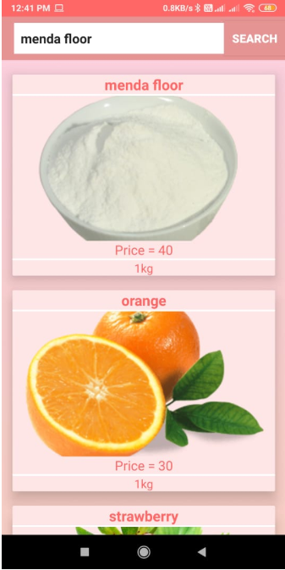

3. completion of project

References:

https://help.liferay.com/hc/en-us/articles/360018183551-Forgot-Password-Screenlet-for-Android

https://stackoverflow.com/questions/23440435/how-to-create-forgot-password-in-android

https://developer.android.com/guide/topics/ui/dialogs

https://developer.android.com/guide/topics/search/search-dialog

https://developer.android.com/training/search/search

Signature of External Supervisor Signature of Internal Supervisor

